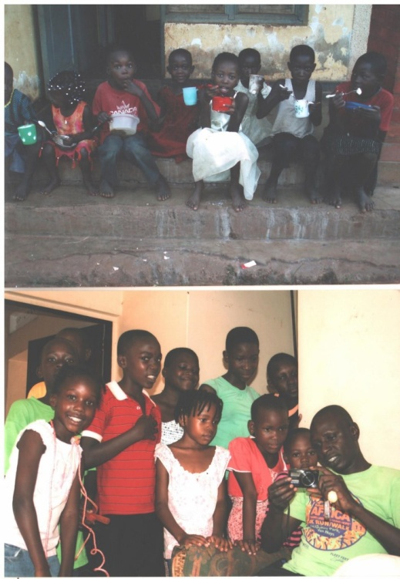

Above group photo in 2006 at home muvule cresent and below in 2011 at home in bukaya.

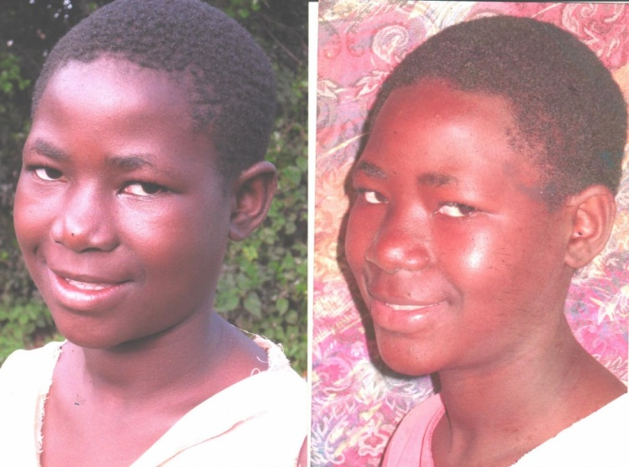

ESTHER NAMUGANZA

She was abandoned by her mother in hospital and shalom baby home took care of her till she was four years.They keep children up to age four and they net work with other homes that keep children above that age.So through a social worker from shalom we took on Esther.She is now in senoir one.

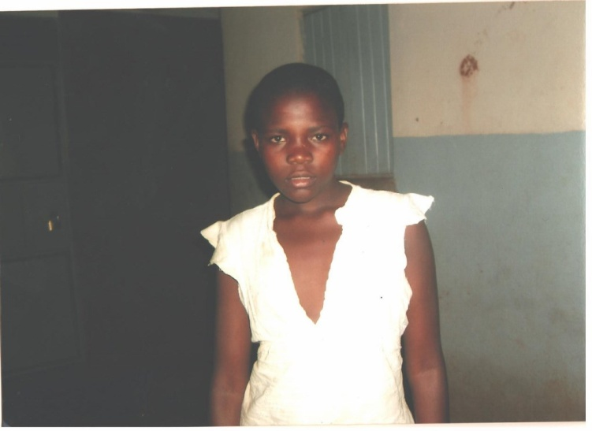

SARAH ADIKINI

She had dropped out of school and was doing causal laborer in order to earn a some income and sustain the family. Her mother died and father was alcoholic with no income. She is a victim of child labour.She is now in primary 7.

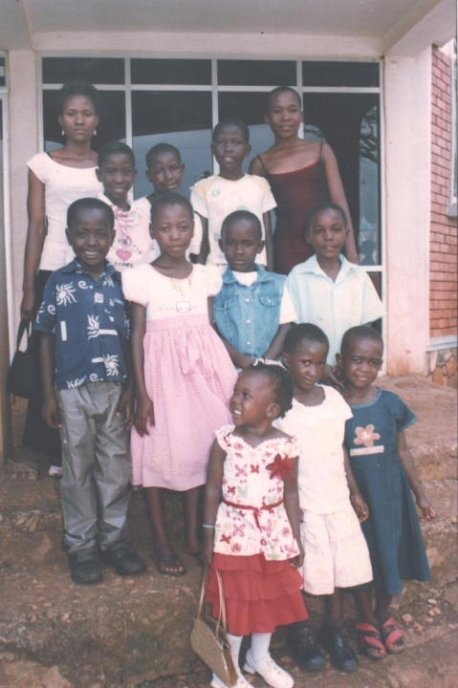

From left to right Ruth,Racheal,Eseza,Prossy,Kevin,Jerioth,John,Eddy,Christiana,Jane and Fiona at church.

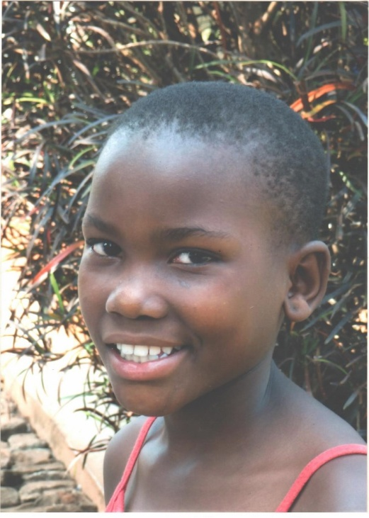

**FIONA MIREMBE**

Her mother died and left her with an ailing Father who passed on 2 years later.She was brought to our attention by some orginisation with whom we net work.We took her on and she is now in primary four.

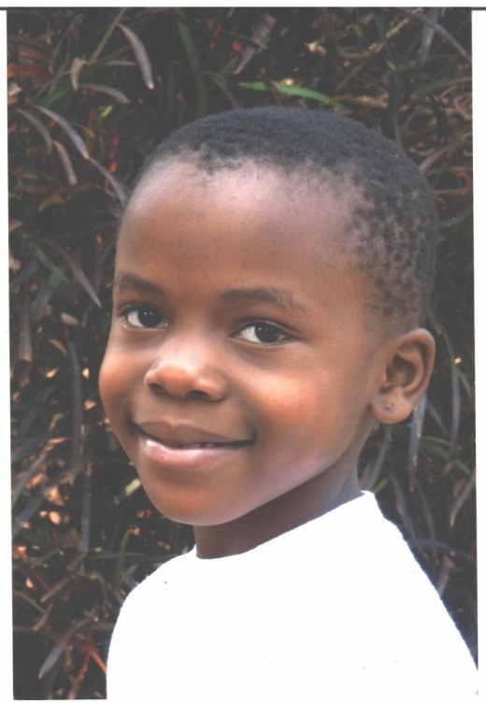

**MARIA TRACY ALIKOBA**

Father very alcholoc and irresposible.The mother we were told left to go and look for greener pastures in Sudan.We found her with her very poor grandmather with many grand children to take care of and no income We took her on and she is now in primary two.